**Title:** Study of BJT biasing circuits.

**Abstract:**

The operating point (Q) of BJT is very important for amplifiers, since a wrong ‘Q’ point selection increases amplifier distortion. It is imperative to have a stable ‘Q’ point, meaning that the operating point should not be sensitive to variation to temperature or BJT ***β***, which can vary widely. In this experiment, four different circuits will be analyzed for two different ***β*** to check the stability of biasing points.

The analysis of the BJT circuits is a systematic process. The parameters of the small signal BJT model are first calculated, after which the operating point of a transistor circuit is established. The circuit is then examined to determine the voltage amplification (AV), current amplification (Ai), input impedance (Zi), output impedance (Zo), and the phase relation between the input voltage (Vi) and the output voltage. The experiment is a very good practical realization of bipolar junction transistor (BJT) biasing circuit. A BJT biasing circuit will be designed and simulated to find DC operation point using a circuit simulation tool.

**Introduction:**

Transistor Biasing is the process of setting a transistors DC operating voltage or current conditions to the correct level so that any AC input signal can be amplified correctly by the transistor. In this experiment we find voltage, current by changing ***β*** in 3 different circuit.

The main objectives of this experiment are to-

1. Establish the proper operating point

2. Study the stability of the operating point with respect to changing ***β*** in different biasing circuits

**Theory and Methodology:**

The dc analysis is done to determine the mode of operation of the BJT and to determine the voltages at all nodes and currents in all branches. The operating point of a transistor circuit can be determined by mathematical or graphical (using transistor characteristic curves) means. Here we will describe only the mathematical solution.

Q

R

C

V

cc

R

B

1

I

c

I

B

I

E

R

B

12

R

C

Q

R

C

V

cc

R

TH

I

c

I

B

I

E

R

C

V

TH

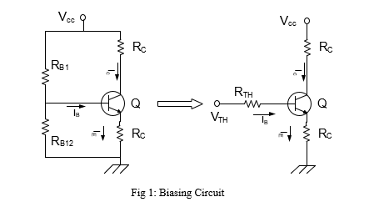

We will use the most commonly applied biasing circuit to operate the BJT as an amplifier. A single power supply is used and the voltage divider network consisting of RB1 and RB2 is used to adjust the base voltage. Using the Thevenin equivalent, the voltage divider network is replaced by Vth and Rth where,



The dc analysis of the circuit is simple by applying two KVL's at the input and the output loop.

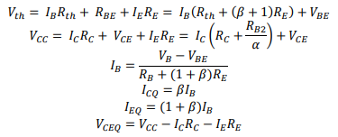

If the BJT is in the active mode the following typical values can be observed:

𝑉𝐵𝐸 ≈ 0.7 𝑉and 𝐼𝐶 ≈ 𝛽𝐼𝐵

RC is used to adjust the collector voltage. Finally, RE is used to stabilize the DC biasing point (operating point). Using the above equations, the stability of biasing points for different transistor of β can be calculated.

**Note:** It is a good idea to set the bias for a single stage amplifier to half the supply voltage, as this allows maximum output voltage swing in both directions ofan output waveform. For maximum symmetrical swing, it is clear from the figures that VCE should be VCE= VCC/2.

**Apparatus:**

1. Trainer board.
2. Transistor.
3. Resistors.

* R=22KΩ [ 1pc ]
* RC= 470Ω [ 1pc ]
* RB1 = 10KΩ [ 1pc]
* RE = 560Ω [1pc]
* RB=500K(Potentiometer

1. DC power supply (VCC = +15VDC)
2. Multimeter.
3. Power supply Cable.

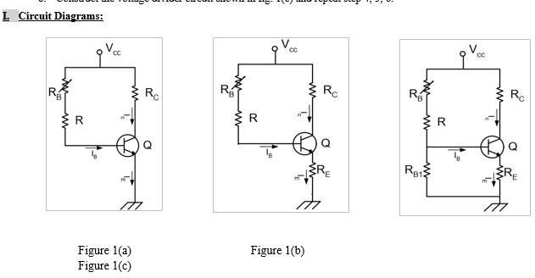

**Discussion and Conclusion:**

1. All the apparatus were checked before the start of the experiment. Care should be taken to avoid short connections. Short connections can produce heat (due to high current flow) which can be harmful for the components and damage the component.
2. The experimental results were slightly different from the simulated results which could happen due to improper connection, contact resistance and variation of source power.
3. From the data it can be concluded that self-biased circuits are more stable then fixed-biased circuits.

**Conclusions**

As a conclusion, by using Ohm’s Law we can measured and determine the value of current, voltage and resistor on diode. The forward-bias and the reverse-bias properties of the p-n junction imply that it can be used as a diode. A p-n junction diode allows electric charges to flow in one direction, but not in the opposite direction; negative charges (electrons) can easily flow through the junction from n to p but not from p to n and the reverse is true for holes. For Bipolar Junction Transistor ( BJT )From this experiment, we are able to determine operational range of bipolar junction transistor (BJT).

**Reference(s):**

[1] American International University–Bangladesh (AIUB) Electronic Devices Lab Manual.

[2] A.S. Sedra, K.C. Smith, Microelectronic Circuits, Oxford University Press (1998)

[3] J. Keown, ORCAD PSpice and Circuit Analysis, Prentice Hall Press (2001)

[4] P. Horowitz, W. Hill, The Art of Electronics, Cambridge University Press (1989).

**Calculation:**

We know, IC= VCC -VCE/RC

IB= VCC -VCE/RC

% of change for IC = VC1 – VC2/VC1

IB = VB1 – VB2/VB1

**Fig 1(a):** IC = = 15.95

IC = = 15.88

**% of change:** IC= x 100 = 1.06 %

IB=  x 100 = 2.68 %

**Fig 2(b):** IC = = 15.77

IB = = 15.91

**% of change:** IC= x 100 = 0.92 %

IB=  x 100 = 0.79 %